A000-Eur-France-Menhir-Mobilary-Limestone-3500-2500 BCE

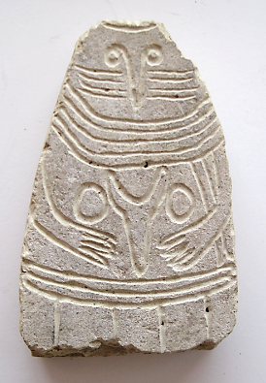

Fig. 1

The identity of these mysterious personages is unclear. Of the three regional groups on the French mainland, only one, the Languedoc group, shows any association with settlement site or burial monuments. The others, especially the Rouergue group, are located far from contemporary settlement sites in relatively remote areas of upland. This has led to the suggestion that they represent deities. Breasts on a few examples indicate that some of the statue-menhirs are female; others are considered male from the presence of weapons, though it is quite possible that these were also used by women at this time. The universal absence of a mouth is a feature that may indicate the ritual or belief associated with the monuments.

The south French and Alpine statue-menhirs are dated to the late Neolithic and Chalcolithic Periods (ca. 3500–2500 B.C.). This is shown both by the objects depicted on the stones and by the occasional discovery of a statue-menhir in a sealed archaeological context. At Euzet, Gravas and Montferrand statue-menhirs have been found among the remains of prehistoric farming villages dated to this period.

**Case no.: 3**

**Accession Number:**

**Formal Label:**

**Display Description:**

**LC Classification:**

**Date or Time Horizon:**

**Geographical Area:**

**Map:**

**GPS coordinates:**

**Cultural Affiliation:**

**Media:**

**Dimensions:** **13 x 9  x 4  cm**

**Weight:**

**Condition:**

**Provenance:**

**Discussion:**

**Similar examples may be found** at Musée Fenaille, Rodez, Aveyron. Fro example:

La Dame de Saint-Sernin, statue-menhir rouergate.

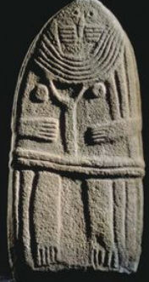

After https://i.pinimg.com/236x/fb/45/59/fb4559a694a1d7edcad02620a76b1408--statue-destinations.jpg

**References:**

**APPENDIX**

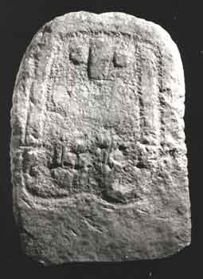  
A statue menhir from Montpellier in southern France



• [Collection of prehistory of the Musée de la préhistoire des gorges du Verdon](https://commons.wikimedia.org/wiki/Category:Collection_of_prehistory_of_the_Mus%C3%A9e_de_la_pr%C3%A9histoire_des_gorges_du_Verdon)

• [Neolithic steles](https://commons.wikimedia.org/wiki/Category:Neolithic_steles)

• [Statue menhirs in Alpes-de-Haute-Provence](https://commons.wikimedia.org/wiki/Category:Statue_menhirs_in_Alpes-de-Haute-Provence)